A
Industrial-Oriented Mini Project
On
AN INTEGRATED ENVIRONMENT ANALYSIS SYSTEM FOR PLANT MONITORING USING IOT
(Submitted in partial fulfilment of the requirements for the award of Degree)
BACHELOR OF TECHNOLOGY
In
COMPUTER SCIENCE AND ENGINEERING
Bainagari Vaishnavi | 237R1A05L1
Jogi Abhishek | 237R1A05M1
Gosukula Padma | 247R5A0524
By

Under the Guidance of
Dr. K. Maheswari
(Associate Professor)


DEPARTMENT OF COMPUTER SCIENCE AND ENGINEERING
CMR TECHNICAL CAMPUS
UGC AUTONOMOUS
(Accredited by NAAC, NBA, Permanently Affiliated to JNTUH, Approved by AICTE, New Delhi) Recognized Under Section 2(f) & 12(B) of the UGCAct.1956,
Kandlakoya (V), Medchal Road, Hyderabad-501401.
April-2026

DEPARTMENT OF COMPUTER SCIENCE AND ENGINEERING

CERTIFICATE

This is to certify that the project entitled “AN INTEGRATED ENVIRONMENT ANALYSIS SYSTEM FOR PLANT MONITORING USING IOT” being submitted by Bainagari Vaishnavi(237R1A05L1), Jogi Abhishek(237R1A05M1) & Gosukula Padma(247R5A0524) in partial fulfilment of the requirements for the award of the degree of B.Tech in Computer Science and Engineering to the Jawaharlal Nehru Technological University Hyderabad, during the year 2025-26.

The results embodied in this thesis have not been submitted to any other University or Institute for the award of any degree or diploma.

Dr. K. Maheswari | Dr. Nuthanakanti Bhaskar
Associate Professor | HoD
INTERNAL GUIDE

Dr. A. Raji Reddy | Signature of External Examiner
DIRECTOR

Submitted for viva voice Examination held on

ACKNOWLEDGEMENT
We take this opportunity to express our gratitude to the people who have been instrumental in the successful completion of this project, we take this opportunity to express our profound gratitude and deep regard to our guide Dr. K. Maheswari Associate Professor for her exemplary guidance, monitoring and constant encouragement throughout the project work. The blessing, help and guidance given by her shall carry us a long way in the journey of life on which we are about to embark.
We take this opportunity to extend our heartfelt appreciation to the Project Review Committee (PRC) Coordinators Dr. Mantesh Patil, Ms. Tabeen Fatima, Mrs. Saba Sultana, Dr. Venkateshwarlu Naik and Mrs. M. Sunitha for their unwavering support, insightful guidance, and valuable inputs, which played a crucial role in steering this project through its various stages.
Our sincere appreciation also goes to Dr. Nuthanakanti Bhaskar, Head, for his encouragement and continuous support in ensuring the successful completion of our project.
We are deeply grateful to Dr. A. Raji Reddy, Director, for his cooperation throughout the course of this project. Additionally, we extend our profound gratitude to Sri. Ch. Gopal Reddy, Chairman, Smt. C. Vasantha Latha, Secretary and Sri. C. Abhinav Reddy, Vice-Chairman, for fostering an excellent infrastructure and a conducive learning environment that greatly contributed to our progress.
We also acknowledge and appreciate the guidance and assistance provided by the faculty and staff of CMR Technical Campus, whose contributions have been invaluable in bringing this project to fruition.
Lastly, we sincerely thank our families for their unwavering support and encouragement. We also extend our gratitude to the teaching and non-teaching staff of CMR Technical Campus for their guidance and assistance. Their contributions, along with the support of everyone who helped directly or indirectly, have been invaluable in the successful completion of this project.
Bainagari Vaishnavi | 237R1A05L1
Jogi Abhishek | 237R1A05M1
Gosukula Padma | 247R5A0524

VISION AND MISSION

INSTITUTE VISION:
To Impart quality education in serene atmosphere thus strive for excellence in Technology and Research.

INSTITUTE MISSION:
1. To create state of art facilities for effective Teaching- Learning Process.
2. Pursue and Disseminate Knowledge based research to meet the needs of Industry & Society.
3. Infuse Professional, Ethical and Societal values among Learning Community.

DEPARTMENT VISION:
To provide quality education and a conducive learning environment in computer engineering that foster critical thinking, creativity, and practical problem-solving skills.

DEPARTMENT MISSION:
1. To educate the students in fundamental principles of computing and induce the skills needed to solve practical problems.
2. To provide State-of-the-art computing laboratory facilities to promote industry institute interaction to enhance student’s practical knowledge.
3. To inculcate self-learning abilities, team spirit, and professional ethics among the students to serve society.

ABSTRACT

The Integrated Environment Analysis System for Plant Growth Monitoring using IoT is a smart agriculture solution designed to enhance plant growth by continuously monitoring environmental conditions. The system employs various sensors to measure critical parameters such as soil moisture, temperature, humidity, and light intensity. These sensors are interfaced with an IoT-enabled microcontroller that processes and transmits the collected data to a cloud server through wireless communication. The data is visualized on a web or mobile dashboard, allowing users to remotely observe plant health and environmental trends in real time. Alerts and notifications can be generated when parameters exceed predefined thresholds, enabling timely intervention. This system reduces human effort, improves resource utilization, and supports precision farming practices. By integrating IoT technology with environmental analysis, the proposed solution contributes to sustainable agriculture and improved crop productivity.The system utilizes various sensors such as soil moisture, temperature, humidity, and light intensity sensors to continuously collect environmental data. These sensors are interfaced with an ESP32 microcontroller, which processes the data and transmits it to a cloud platform using wireless communication.The collected data is stored and visualized on a web or mobile dashboard, enabling users to monitor plant conditions remotely from anywhere. Overall, the proposed system improves resource utilization, supports data-driven decision-making, and promotes sustainable and precision agriculture practices. It is suitable for both small-scale gardening and large-scale farming, providing a reliable, scalable, and cost-effective solution for modern agricultural needs.

i
LIST OF FIGURES
ii

FIGURE NO | FIGURE NAME | PAGE NO
Figure 3.1 | Block Diagram of the project | 12
Figure 3.2 | ESP32 module | 15
Figure 3.3 | Pin diagram of 1x16 lines lcd | 16
Figure 3.4 | Sensors used for Arduino | 16
Figure 3.5 | DHT11 sensor | 16
Figure 3.6 | Light Dependent Resistor | 17
Figure 3.7 | Motor | 17
Figure 3.8 | Active Passive Buzzer | 18
Figure 3.9 | Data Flow Diagram of the System | 20
Figure 5.1 | Providing power supply to the | 31
Figure 5.2 | Results of the project | 32
Figure 5.3 | Cloud monitoring result of the system | 32

LIST OF TABLES

TABLE NO | TABLE NAME | PAGE NO
Table 3.1 | Address locations for a 1x16 line LCD | 15
Table 6.1 | Uploading dataset | 34

iii
TABLE OF CONTENTS
ABSTRACT | i
LIST OF FIGURES | ii
LIST OF TABLES | iii
1. INTRODUCTION | 1
1.1 PROJECT PURPOSE | 1
1.2 PROJECT FEATURES | 2
2. LITERATURE SURVEY | 3
2.1 REVIEW OF RELATED WORK | 4
2.2 DEFINITION OF PROBLEM STATEMENT | 5
2.3 EXISTING SYSTEM | 6
2.4 PROPOSED SYSTEM | 8
2.5 OBJECTIVES | 8
2.6 HARDWARE & SOFTWARE REQUIREMENTS | 9
2.6.1 HARDWARE REQUIREMENTS | 9
2.6.2 SOFTWARE REQUIREMENTS | 10
3. SYSTEM ARCHITECTURE & DESIGN | 12
3.1 PROJECT ARCHITECTURE | 12
3.2 DESCRIPTION | 13
3.3 DATA FLOW DIAGRAM | 20
4. IMPLEMENTATION | 26
4.1 WORKING PRINCIPLE | 21
4.2 ALGORITHM USED | 22
4.3 ARDUINO CODE | 26
5. RESULTS & DISCUSSION | 31
5.1 GUI/MAIN INTERFACE | 31
5.2 ENVIRONMENTAL CONDITIONS | 32
6. VALIDATION | 33
6.1 VALIDATION | 33
6.2 TEST CASES | 34
7. CONCLUSION & FUTURE ASPECTS | 35
7.1 PROJECT CONCLUSION | 35
7.2 FUTURE ASPECTS | 36
8. BIBLIOGRAPHY | 37
8.1 REFERENCES | 37
8.2 GITHUB LINK | 38

1.INTRODUCTION
1.INTRODUCTION
The Integrated Environment Analysis System for Plant Growth Monitoring using IoT leverages sensor technology, embedded systems, and cloud computing to create an intelligent monitoring platform. As represented in the block diagram, the system consists of environmental sensors connected to a microcontroller unit, which acts as the core processing block. The sensors continuously collect real-time data related to plant growth conditions. This data is processed and transmitted through a wireless communication module to a cloud server.
The cloud platform stores the data and provides analytical tools for visualization and trend analysis. Farmers, researchers, or users can access this information through a web or mobile interface from anywhere. Based on the analyzed data, timely alerts can be generated to inform users about unfavorable conditions, enabling immediate corrective actions such as irrigation or shading.
By automating data collection and analysis, the system reduces manual labor and minimizes resource wastage. It also supports precision farming by enabling data-driven decisions. This IoT-based approach enhances productivity, promotes sustainable agricultural practices, and ensures healthier plant growth in both small-scale gardens and large-scale farming environments.
1.1 PROJECT PURPOSE
The purpose of this project is to develop a smart, automated system that continuously monitors environmental conditions affecting plant growth using IoT technology. Traditional methods rely on manual observation, which can be inaccurate and time-consuming. This system uses sensors to measure key parameters such as soil moisture, temperature, humidity, and light intensity in real time. The collected data is processed by a microcontroller and transmitted to a cloud platform, enabling users to monitor plant conditions remotely and accurately
Another important purpose of the project is to improve agricultural efficiency and support data-driven decision-making. By providing real-time insights and alerts when environmental conditions go beyond optimal levels, the system helps in taking timely actions like irrigation or adjusting light exposure. This not only enhances plant health and crop yield but also ensures efficient use of resources such as water and energy, promoting sustainable and precision farming practices.
1.2 PROJECT FEATURES
The project features a real-time environmental monitoring system that continuously tracks essential parameters affecting plant growth, such as soil moisture, temperature, humidity, and light intensity. By using multiple sensors, the system ensures accurate and up-to-date data collection, allowing users to understand the exact condition of their plants at any moment without manual inspection.
Another key feature is the integration of an IoT-enabled microcontroller (such as ESP32), which processes sensor data and transmits it wirelessly to a cloud platform. This connectivity enables seamless communication between hardware and software components, making the system efficient, reliable, and capable of handling continuous data flow for smart agriculture applications.
The system also provides remote monitoring capabilities through a web or mobile dashboard. Users can access real-time data, view trends, and analyze plant growth conditions from anywhere, eliminating the need for physical presence. This feature is especially useful for large-scale farming or greenhouse management where constant supervision is difficult.
An important feature of the project is its alert and notification mechanism. When any environmental parameter exceeds or drops below predefined threshold levels, the system automatically sends alerts to the user. This helps in taking immediate corrective actions, such as watering the plants or adjusting environmental conditions, thereby preventing potential damage.
Additionally, the project promotes efficient resource management and sustainability. By providing accurate data and enabling automation, it reduces unnecessary water usage, minimizes human effort, and improves overall productivity. The system supports precision farming practices, making it suitable for both small-scale gardening and large agricultural environments
2.LITERATURE SURVEY
2.LITERATURE SURVEY

1. IoT-Based Plant Growth Monitoring System
Authors: Saymaharan Mohan & Nureize Arbaiy
Description: This study proposes a real-time IoT system for monitoring plant growth by collecting environmental variables such as temperature, humidity, soil moisture, light, and rainfall using multiple sensors. The data is processed for real-time monitoring and control, aiming to improve plant care, production, and decision-making under fluctuating weather conditions.
2. Development of an IoT-Based SCADA System for Monitoring of Plant Leaf Temperature and Air and Soil Parameters
Authors: (from research article)
Description: Develops an IoT-integrated SCADA platform to monitor crucial plant and environmental parameters like leaf temperature, air temperature/humidity, soil moisture, pH, and nutrients. It uses low-cost sensors including a thermal camera and DHT22, transmitting data via IoT for continuous growth analysis and system visualization.
3. IoT-Based Monitoring System Applied to Aeroponics Greenhouse
Authors: Hugo A. Méndez-Guzmán, José A. Padilla-Medina, Coral Martínez-Nolasco, Juan J. Martinez-Nolasco, Alejandro I. Barranco-Gutiérrez, Luis M. Contreras-Medina & Miguel Leon-Rodriguez
Description: Focuses on an IoT environment in an aeroponics greenhouse, where sensor networks collect environmental data to optimize growth conditions. This system integrates IoT sensing for climate control in a controlled plant growth environment, improving automation and yield efficiency.
4. IoT Enabled Plant Monitoring System
Authors: Vedant Banke, Divesh Lende, Ganesh Masal, Sahil Shevade & Gaurav Thamke
Description: Describes a practical IoT plant monitoring system using sensors to track soil moisture, temperature, and humidity. Sensor data is shared via network modules (e.g., NodeMCU), enabling real-time environmental feedback that supports smart irrigation, environmental analysis, and plant growth optimization.
5. Design and Development of an IoT Based Plant Growth Monitoring and Management System for Indoor Farming
Authors: Safa Yousif Abdalla, Hariprasad Yogaraju & Sandhya Rai
Description: Addresses indoor farming challenges by developing an IoT system for growth monitoring and automated watering. Integrated sensors track key environmental conditions to ensure optimal plant health and automate daily maintenance tasks, bridging gaps in manual care with data-driven environmental control.

2.1 REVIEW OF RELATED WORK
Limitations of Manual Plant Monitoring
Peering over growings often means scanning plots by schedule, relying solely on eyes that watch but never stretch beyond human reach. Even if workers stroll through rows daily, slips happen - especially under swift shifts in weather or warmth. Things like wet ground texture, air dampness, sun strength, or how hot it feels can slip past unnoticed since no device follows changes minute by minute. Farming gets delayed, so signs of trouble on plants go unseen until damage already happens.

Problems in Farming Today
Big farms make things harder because checking each part by hand just does not work. People can watch only so much before mistakes happen too often. Early signals slip through when humans cannot keep up with demands. If warnings

Manual and Periodic Monitoring Approach
Right now, how plants grow gets checked by people looking at them now and then. A farmer or someone growing things sees the greenery up close, using basic gadgets to see how wet the dirt is, what the heat or cold feels like, or how damp the air feels. Because everything runs on individuals doing steps themselves, results often miss the mark - timing gets messy, numbers waver. Watching every single day just isn’t possible here.

Lack of automation slows things down. Real time insights are missing too.
Farmers find it hard to keep up when old methods miss out on tools like automatic tracking or analysis from afar. Real-time updates on leaf temperature or soil moisture stay beyond reach here. Without alerts for shifting weather patterns, reactions lag behind what's actually happening underground. Water gets wasted more than expected simply because adjustments come too late. Stress in seedlings goes unseen longer than necessary due to missing early signals. Growing conditions receive uneven care simply because feedback loops are slow or incomplete. Health of harvests tends to dip under these constraints over time.

Absence of Data Management and Alerts
A big problem comes from having scattered data sources with no single hub to manage them. Because information is not collected or stored uniformly, spotting patterns across months or seasons turns into a challenge. When insights are hard to gather, choosing effective ways to boost crops feels uncertain. What tends to slip through the cracks is how alerts fail to reach people right when something needs attention. Missing early signals means farmers react too late - which can cut harvests short while supplies go unused.

2.2 DEFINITION OF PROBLEM STATEMENT

Traditional plant growth monitoring relies heavily on manual observation and periodic inspection, which often leads to inaccurate assessment of environmental conditions such as soil moisture, temperature, humidity, and light intensity. These methods are time-consuming, prone to human error, and unsuitable for large-scale agriculture or precision farming. Unfavorable environmental conditions may go unnoticed for long periods, resulting in reduced crop yield, inefficient use of water and fertilizers, and delayed corrective actions. There is a critical need for an automated, real-time, and intelligent system that continuously analyzes environmental parameters affecting plant growth and provides actionable insights to farmers or gardeners.

2.3 EXISTING SYSTEM
In the existing system, plant growth monitoring is largely dependent on traditional farming practices where farmers rely on visual inspection and experience-based decisions. Environmental factors such as soil moisture, temperature, and humidity are not continuously monitored, which makes it difficult to maintain optimal growing conditions. This lack of precise measurement often results in inconsistent plant care and reduced efficiency in managing crops.
Additionally, traditional systems lack real-time monitoring, automation, and remote accessibility. There is no centralized data storage or continuous tracking of environmental conditions, making it difficult to identify trends or take timely action when conditions become unfavorable. As a result, issues like overwatering, poor soil conditions, or extreme weather changes may go unnoticed, leading to reduced crop yield, inefficient resource usage, and overall lower productivity.
Moreover, these conventional methods do not support automation or intelligent decision-making. There is no provision for real-time alerts or data analysis, which means corrective actions are often delayed. The absence of digital integration and remote monitoring capabilities limits scalability, especially in large agricultural fields. Consequently, this leads to wastage of resources like water and fertilizers, increased labor effort, and lower overall productivity in farming practices.
Limitations of Existing System
- Manual Monitoring
The existing system depends entirely on farmers or gardeners to physically inspect plant conditions. This process requires regular field visits, which consume significant time and effort. In large-scale farms, it becomes even more difficult to monitor every plant consistently, leading to uneven observation and missed problem areas.

- Lack of Real-Time Data
Environmental parameters such as soil moisture, temperature, and humidity are checked only at specific intervals rather than continuously. As a result, sudden changes in weather or soil conditions may go unnoticed for long periods. This delay in identifying issues can negatively affect plant health and reduce overall productivity.

- Human Error
Since monitoring and decision-making are based on human judgment, there is a high possibility of errors. Different individuals may interpret plant conditions differently, leading to inconsistent actions. Factors like fatigue, lack of experience, or oversight can further increase the chances of incorrect assessments.

- No Remote Accessibility
Traditional systems require the user to be physically present at the location to monitor plant conditions. This becomes inconvenient for farmers managing multiple fields or those who cannot visit regularly. The lack of remote access limits flexibility and prevents timely intervention when problems arise.

- Absence of Automation
There are no automated mechanisms to control irrigation, lighting, or other environmental factors. All actions must be performed manually, which increases workload and reduces efficiency. This also makes it difficult to maintain optimal growing conditions consistently, especially in changing environments.

- Inefficient Resource Usage
Without precise data, resources like water, fertilizers, and energy are often used inefficiently. Overwatering or under-watering is common, leading to wastage or poor plant growth. Similarly, improper use of fertilizers can affect soil health and increase operational costs.

- No Data Storage or Analysis
Traditional monitoring systems do not maintain historical records of environmental conditions. Without stored data, it is difficult to analyze patterns, predict future conditions, or improve farming strategies. This lack of data-driven insight limits the ability to adopt advanced agricultural practices.
2.4 PROPOSED SYSTEM
The proposed system introduces an IoT-based integrated environment analysis platform for plant growth monitoring. As shown in the block diagram, sensors for soil moisture, temperature, humidity, and light intensity are connected to an IoT microcontroller. The controller processes sensor data and transmits it to a cloud server via wireless communication. The cloud platform enables real-time visualization, data logging, and analysis through a user-friendly dashboard. Automated alerts notify users when parameters cross critical thresholds. This system ensures continuous monitoring, remote accessibility, improved accuracy, and efficient resource management, making it suitable for smart agriculture and precision farming applications.
2.5 ADVANTAGES OF THE PROPOSED SYSTEM:
- Real-Time Monitoring
The system continuously monitors environmental parameters such as soil moisture, temperature, humidity, and light intensity. This ensures that users receive up-to-date information about plant conditions, enabling quick identification of any unfavorable changes.
- Reduced Human Effort
Automation of data collection and monitoring significantly reduces the need for manual inspection. Farmers and users can save time and effort, as the system performs continuous tracking without requiring physical presence in the field.

- Remote Accessibility
The system allows users to monitor plant conditions from anywhere through a web or mobile interface. This is especially beneficial for large-scale farming, as it eliminates the need for constant on-site supervision.
- Efficient Resource Utilization
By providing accurate data, the system helps in optimizing the use of water, fertilizers, and energy. It prevents overuse or underuse of resources, leading to cost savings and improved sustainability.
- Automated Alerts and Notifications
The system generates alerts when environmental parameters cross predefined threshold levels. This helps users take immediate corrective actions, reducing the risk of plant damage and improving crop health.
- Improved Crop Yield and Quality
Maintaining optimal environmental conditions leads to healthier plant growth. As a result, the system contributes to higher crop yield and better quality produce.

OBJECTIVE
The main objective of the Integrated Environment Analysis System for Plant Growth Monitoring using IoT is to design and develop a smart, automated monitoring platform that continuously measures key environmental parameters influencing plant health. The system aims to collect real-time data from multiple sensors, process the data using an IoT-enabled microcontroller, and transmit it to a cloud platform for storage, visualization, and analysis. By enabling remote monitoring and timely alerts, the system seeks to improve plant growth efficiency, optimize resource usage such as water and energy, and support data-driven decision-making for sustainable agriculture.
2.6 HARDWARE & SOFTWARE REQUIREMENTS
2.6.1 HARDWARE REQUIREMENTS:
Hardware interfaces specifies the logical characteristics of each interface between the software product and the hardware components of the system. The following are some hardware requirements,
• LDR Light Sensor – Measures the intensity of light around the plant.

• 16×2 LCD Display – Displays the sensor readings and system status.

• Relay Module – Controls devices like the water pump and fan automatically.

• Water Pump – Supplies water to plants when the soil becomes dry.

• Cooling Fan – Helps maintain proper temperature around the plan

2.6.2 SOFTWARE REQUIREMENTS:

Software Requirements specifies the logical characteristics of each interface and software components of the system. The following are some software requirements,

Operating System (Windows 10 / Windows 11) – Provides the platform required to run the development tools and IoT software.

Arduino IDE – Used to write, compile, and upload the program to the NodeMCU microcontroller.

Programming Language (Embedded C / Arduino Language) – Used to develop the program that controls sensors and system operations.

IoT Libraries (ESP8266 Wi-Fi Libraries) – Enable wireless communication between the NodeMCU and the cloud server.

Sensor Libraries (DHT Library) – Used to read temperature and humidity data from the DHT11 sensor.

LCD Library (LiquidCrystal Library) – Helps display sensor readings and system information on the LCD screen.

Serial Monitor (Arduino IDE) – Used to display sensor values and debug the system during development.

Cloud Platform / IoT Dashboard – Used to store, monitor, and analyze environmental data remotely.

Web Browser (Google Chrome / Microsoft Edge) – Used to access the IoT dashboard and monitor plant conditions online.

3. SYSTEM ARCHITECTURE & DESIGN
3. SYSTEM ARCHITECTURE & DESIGN

Project architecture refers to the structural framework and design of a project, encompassing its components, interactions, and overall organization. It provides a clear blueprint for development, ensuring efficiency, scalability, and alignment with project goals. Effective architecture guides the project's lifecycle, from planning to execution, enhancing collaboration and reducing complexity.

3.1 BLOCK DIAGRAM

This project architecture shows the procedure followed by Integrated Environment

Analysis System using IOT
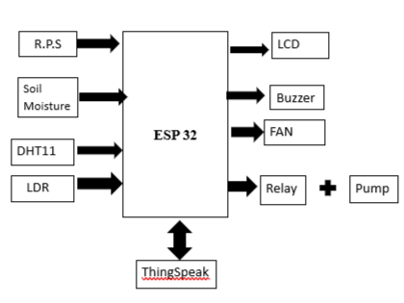

Figure 3.1 : Block Diagram of the project

3.2 DESIGN PROCESS
Embedded system design is a quantitative job. The pillars of the system design methodology are the separation between function and architecture, is an essential step from conception to implementation. In recent past, the search and industrial community has paid significant attention to the topic of hardware-software (HW/SW) codesign and has tackled the problem of coordinating the design of the parts to be implemented as software and the parts to be implemented as hardware avoiding the HW/SW integration problem marred the electronics system industry so long. Formal models & transformations in system design are used so that verification and synthesis can be applied to advantage in the design methodology.
- SPECIFICATION
During this part of the design process, the informal requirements of the analysis are transformed to formal specification using SDL.
- SYSTEM-SYNTHESIS
For performing an automatic HW/SW partitioning, the system synthesis step translates the SDL specification to an internal system model switch contains problem graph& architecture graph. After system synthesis, the resulting system model is translated back to SDL.
- IMPLEMENTATION-SYNTHESIS
SDL specification is then translated into conventional implementation languages such as VHDL for hardware modules and C for software parts of the system.
- PROTOTYPING
On a prototyping platform, the implementation of the system under development is executed with the software parts running on multiprocessor unit and the hardware part running on a FPGA board known as phoenix, prototype hardware for Embedded Network Interconnect Accelerators.
- APPLICATIONS
Embedded systems are finding their way into robotic toys and electronic pets, intelligent cars and remote controllable home appliances. ‘Furby’ and ‘AIBO’ are good examples at this kind. The AIBO is robotic dog. Embedded systems in cars also known as Telematic Systems are used to provide navigational security communication.
FEATURED SOLUTIONS
Ultra LowPower Solution ESP32 is designed for mobile, wearable electronics, and Internet-of-Things (IoT) applications. It features all the state-of-the-art characteristics of low-power chips, including fine-grained clock gating, multiple power modes, and dynamic power scaling. For instance, in a low-power IoT sensor hub application scenario, ESP32 is woken up periodically and only when a specified condition is detected. Low-duty cycle is used to minimize the amount of energy that the chip expends. The output of the power amplifier is also adjustable, thus contributing to an optimal trade-off between communication range, data rate and power consumption
Complete Integration Solution ESP32 is a highly-integrated solution for Wi-Fi-and-Bluetooth IoT applications, with around 20 external components. ESP32 integrates an antenna switch, RF balun, power amplifier, low-noise receive amplifier, filters, and power management modules. As such, the entire solution occupies minimal Printed Circuit Board (PCB) area. ESP32 uses CMOS for single-chip fully-integrated radio and baseband, while also integrating advanced calibration circuitries that allow the solution to remove external circuit imperfections or adjust to changes in external conditions.
As such, the mass production of ESP32 solutions does not require expensive and specialized Wi-Fi testing equipment.
ESP32
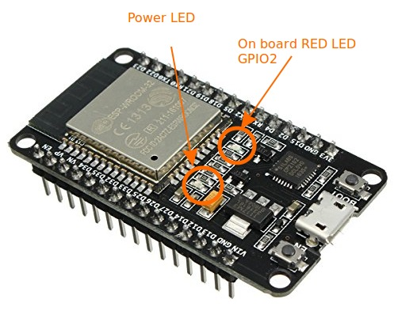
ESP32-WROOM-32 is a powerful, generic Wi-Fi+BT+BLE MCU module that targets a wide variety of applications, ranging from low-power sensor networks to the most demanding tasks, such as voice encoding, music streaming and MP3 decodingESP32 is a single 2.4 GHz Wi-Fi-and-Bluetooth combo chip designed with the TSMC ultra-low-power 40 nm technology. The ESP32 series of chips includes ESP32-D0WD-V3, ESP32-D0WDQ6-V3, ESP32-D0WD, ESP32-D0WDQ6, ESP32-D2WD, ESP32-S0WD, and ESP32-U4WDH, among which, ESP32-D0WD-V3, ESP32-D0WDQ6-V3, and ESP32-U4WDH are based on ECO V3 wafer.

Figure 3.2: ESP Module
LCD (Liquid Crystal Display)
A liquid crystal display (LCD) is a thin, flat display device made up of any number of color or monochrome pixels arrayed in front of a light source or reflector. Each pixel consists of a column of liquid crystal molecules suspended between two transparent electrodes, and two polarizing filters, the axes of polarity of which are perpendicular to each other. Without the liquid crystals between them, light passing through one would be blocked by the other. The liquid crystal twists the polarization of light entering one filter to allow it to pass through the other.
Data can be placed at any location on the LCD. For 16×1 LCD, the address locations are:
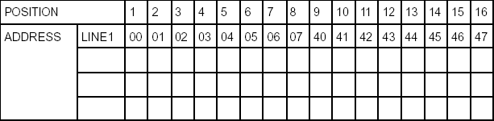
Table 3.1 : Address locations for a 1x16 line LCD
PIN DESCRIPTION:
Most LCDs with 1 controller has 14 Pins and LCDs with 2 controller has 16 Pins (two pins are extra in both for back-light LED connections).
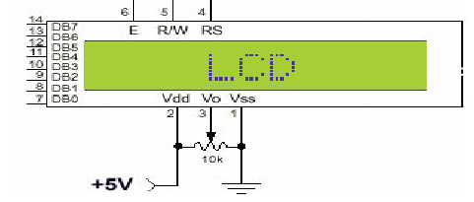
Figure 3.3: Pin diagram of 1x16 lines lcd
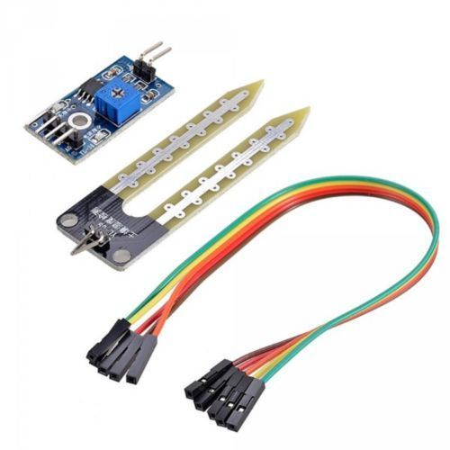

Figure 3.4: Sensors used for Arduino
DHT TEMPERATURE & HUMIDITY SENSORS.
These sensors are very basic and slow, but are great for hobbyists who want to do some basic data logging. The DHT sensors are made of two parts, a capacitive humidity sensor and a thermistor. There is also a very basic chip inside that does some analog to digital conversion and spits outdigital signal with the temperature and humidity. The digital signal is fairly easy to read using
any microcontroller
. 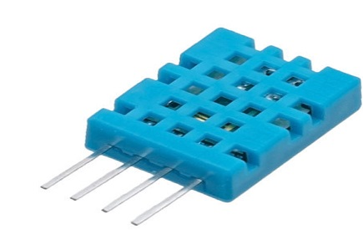
Figure 3.5: DHT11 Sensor

LDR WORKING PRINCIPLE
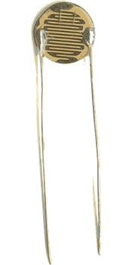
It works on the principle of photoconductivity whenever the light falls on its photoconductive material, it absorbs its energy and the electrons of that photoconductive material in the valence band get excited and go to the conduction band and thus increasing the conductivity as per the increase in light intensity.

Figure 3.6: Light Dependent Resistor
MOTOR
A DC motor (Direct Current motor) is the most common type of motor. DC motors normally have just two leads, one positive and one negative. If you connect these two leads directly to a battery, the motor will rotate. If you switch the leads, the motor will rotate in the opposite direction.
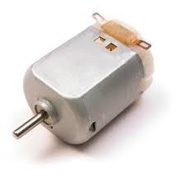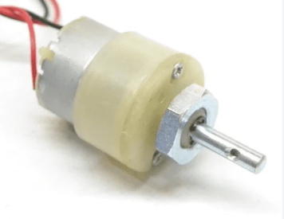
Figure 3.7: Motor
ACTIVE PASSIVE BUZZER
In common parlance a Buzzer is a signaling device that is not a loudspeaker. It can be mechanical, electromechanical, or electronic (a piezo transducer). BeStar produces Buzzers in every available configuration for a wide variety of applications. A Piezo transducer can produce the sound for panel mount buzzers, household goods, medical devices and even very loud sirens.
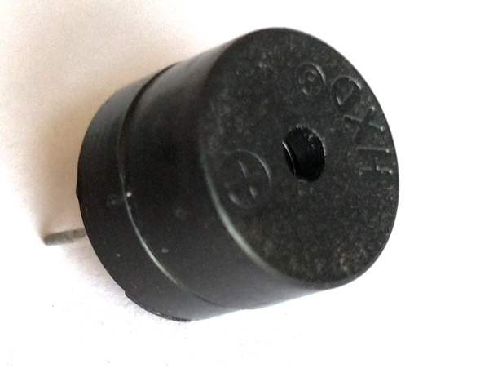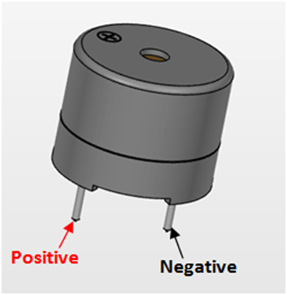
Figure 3.8: Activate Passive Buzzer

3.3 DESCRIPTION

Sensors (Input Section)
Various sensors like soil moisture sensor, DHT11 (temperature & humidity), and LDR (light sensor) are used to collect real-time environmental data affecting plant growth

Data Collection
These sensors continuously sense parameters and send analog or digital signals to the microcontroller.

Microcontroller (Processing Unit)
The ESP32 microcontroller receives data from all sensors, processes it, and converts it into a suitable format for transmission.

Wireless Communication (Wi-Fi Module)
The processed data is transmitted to the cloud using the built-in Wi-Fi feature of the ESP32.

Cloud Server (Storage & Processing)
The cloud platform stores the received data and performs analysis for better understanding of environmental conditions.

User Interface (Dashboard)
Data is displayed on a web or mobile dashboard where users can view real-time values and historical trends.

Alert System
The system sends notifications or alerts when any parameter crosses predefined threshold limits.

User Action / Control
Based on the data and alerts, users can take necessary actions such as watering plants or adjusting environmental conditions.

3.4 DATA FLOW DIAGRAM

Level 0 DFD
- User (Farmer/Gardener)
  - Interacts with the system through a web/mobile interface.
  - Views plant data and receives alerts.
- IoT Plant Monitoring System (Main Process)
  - Central system that collects, processes, and sends data.
- Data Input
  - Environmental data (soil moisture, temperature, humidity, light) from sensors.
- Data Output
  - Processed data, alerts, and notifications sent to the user.

Level 1 DFD
- Sensors → Data Collection
  - Sensors (soil moisture, DHT11, LDR) collect environmental data.
- Data Collection → Microcontroller (ESP32)
  - Raw data is sent to the microcontroller for processing.
- Microcontroller → Data Processing
  - Data is analyzed and compared with predefined threshold values.
- Microcontroller → Cloud Server
  - Processed data is transmitted via Wi-Fi to the cloud.
- Cloud Server → Database Storage
  - Data is stored for future reference and analysis.
- Cloud Server → User Dashboard
  - Data is displayed in graphical or tabular format.
- Cloud Server → Alert System
  - Alerts are generated if parameters exceed limits.
- Alert System → User
  - Notifications are sent to the user (mobile/web).

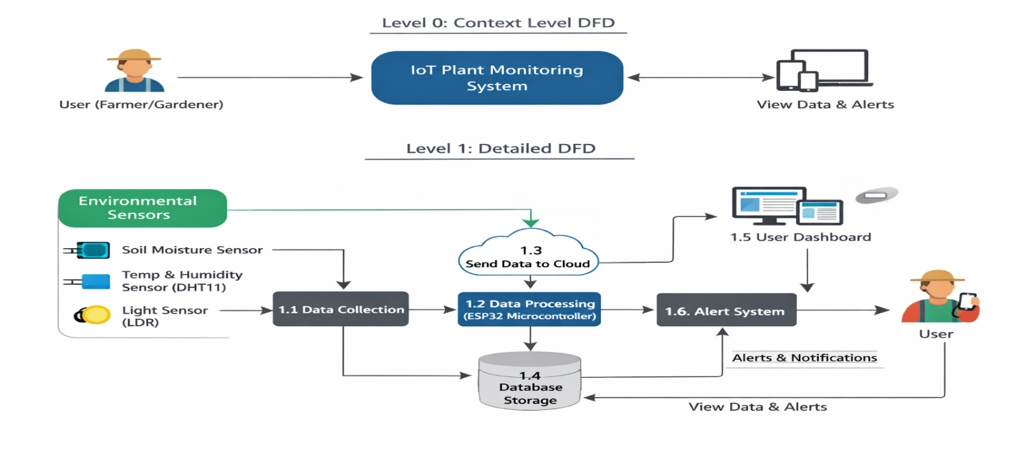
Figure 3.9 Data Flow Diagram of the System

4.IMPLEMENTATION
4.IMPLEMENTATION
The implementation phase of a project involves executing the planned strategies and tasks. It requires meticulous coordination, resource allocation, and monitoring to ensure that objectives are met efficiently. Effective implementation is crucial for achieving project goals and delivering expected outcomes within the set timeline and budget constraints.
4.1 WORKING PEINCIPLE
The Integrated Environment Analysis System for Plant Growth Monitoring using IoT operates on the principle of real-time environmental sensing, data processing, and automated control using an embedded IoT system.
The system consists of multiple sensors such as a temperature and humidity sensor (DHT11), soil moisture sensor, and light-dependent resistor (LDR). These sensors continuously monitor important environmental parameters that affect plant growth.
The collected sensor data is sent to the ESP32 microcontroller, which acts as the central processing unit of the system. The microcontroller reads the sensor values and compares them with predefined threshold limits stored in the program.
Based on this comparison, the system automatically controls different devices:
- If the temperature or humidity exceeds the set limit, the fan is turned ON and a buzzer alert is activated.
- If the soil moisture level is low (dry soil), the water pump is turned ON to irrigate the plant.
- If the soil is wet, the pump is turned OFF to prevent overwatering.
- The LDR detects light intensity and identifies whether the environment is light or dark.
All the real-time data is displayed on an LCD screen for local monitoring. At the same time, the ESP32 uses its built-in WiFi capability to send the data to a cloud server through HTTP requests. This enables users to monitor plant conditions remotely from anywhere.
The entire process runs continuously in a loop, ensuring automatic monitoring, timely decision-making, and efficient resource utilization. This system reduces human effort, improves plant health, and supports smart agriculture practices.
The system uses sensors to continuously monitor environmental parameters:
- Temperature & Humidity → DHT11 sensor
- Soil Moisture → Moisture sensor
- Light Intensity → LDR sensor
These sensors send data to the ESP32 microcontroller.
- The microcontroller:
- Processes the sensor data
- Compares it with predefined threshold values
- Takes automatic decisions
Based on conditions:
- Fan turns ON (high temperature/humidity)
- Pump turns ON (dry soil)
- Buzzer alerts (critical condition)
The system also:
- Displays data on LCD
- Sends data to cloud server using WiFi for remote monitoring
4.2. ALGORITHMS USED
In this approach, the microcontroller continuously reads the sensor values such as temperature, humidity, soil moisture, and light intensity. These values are compared with predefined threshold limits stored in the program. Based on this comparison, the system automatically makes decisions and controls devices like the fan, water pump, and buzzer.
Additionally, the system uses an IoT communication algorithm, where the processed data is sent to a cloud server using WiFi and HTTP requests. This enables remote monitoring and data analysis.
The entire algorithm runs continuously in a loop, ensuring real-time monitoring, automatic control, and efficient resource utilization.
Algorithm Steps
🔹 Step-by-Step Procedure
- Start the system
- Initialize components
  - Sensors (DHT11, Soil Moisture, LDR)
  - LCD display
  - WiFi connection
- Read sensor values
  - Temperature and Humidity
  - Soil Moisture status (Wet/Dry)
  - Light intensity (Light/Dark)
- Display data
  - Show all values on LCD
- Compare with threshold values
  - Check temperature and humidity limits
  - Check soil moisture condition
  - Check light condition
- Control devices
  - If temperature/humidity is high → Turn ON fan and buzzer
  - If soil is dry → Turn ON water pump
  - If soil is wet → Turn OFF pump
- Send data to server
  - Connect via WiFi
  - Send sensor values using HTTP request
- Wait for a short delay
- Repeat the process (loop continuously)
- Stop (only when system is turned OFF)

Algorithm (Pseudo Code)

START
INITIALIZE LCD display
INITIALIZE WiFi connection
INITIALIZE DHT sensor
SET pin modes (buzzer, fan, pump, sensors)

DISPLAY welcome message on LCD

CONNECT to WiFi
WAIT until connected

LOOP forever:

READ temperature from DHT sensor
READ humidity from DHT sensor

DISPLAY temperature and humidity on LCD
IF temperature > 40 OR humidity > 85 THEN
TURN ON fan
ACTIVATE buzzer
SEND data to IoT server
ELSE
TURN OFF fan
ENDIF

READ soil moisture sensor
IF soil is WET THEN
DISPLAY "Wet"
TURN OFF pump
ELSE
DISPLAY "Dry"
TURN ON pump
ENDIF

READ LDR sensor
IF light detected THEN
DISPLAY "Light"
ELSE
DISPLAY "Dark"
ENDIF

WAIT 1 second

INCREMENT counter
IF counter reaches 50 THEN
SEND data to server
RESET counter
ENDIF

END LOOP

END
4.3 ARDUINO CODE

#include <LiquidCrystal.h>
#include <WiFi.h>
#include <HTTPClient.h>
#include "DHT.h"

// LCD
LiquidCrystal lcd(13, 12, 14, 27, 26, 25);

// WiFi
const char* ssid = "iotserver";
const char* password = "iotserver123";
String server = "http://projectsfactoryserver.in/storedata.php?name=iot1681";

// DHT Sensor
#define DHTPIN 19
#define DHTTYPE DHT11
DHT dht(DHTPIN, DHTTYPE);

// Pins
int buzzer = 21;
int fan = 22;
int pump = 23;
int mos = 5;
int ldr = 18;

// Variables
int temp, hum;
String soilStatus, lightStatus;
int counter = 0;

void setup() {
Serial.begin(9600);

pinMode(buzzer, OUTPUT);
pinMode(fan, OUTPUT);
pinMode(pump, OUTPUT);
pinMode(mos, INPUT);
pinMode(ldr, INPUT);

lcd.begin(16, 2);
lcd.print("Env Monitoring");
delay(2000);
lcd.clear();

// WiFi connect
WiFi.begin(ssid, password);
while (WiFi.status() != WL_CONNECTED) {
delay(500);
}

dht.begin();
}

void loop() {

// Read DHT
temp = dht.readTemperature();
hum = dht.readHumidity();

// Display
lcd.setCursor(0, 0);
lcd.print("T:");
lcd.print(temp);
lcd.print(" H:");
lcd.print(hum);
// Temperature control
if (temp > 40 || hum > 85) {
digitalWrite(fan, HIGH);
digitalWrite(buzzer, LOW);
sendData();
} else {
digitalWrite(fan, LOW);
digitalWrite(buzzer, HIGH);
}

// Soil moisture
if (digitalRead(mos) == LOW) {
soilStatus = "Wet";
digitalWrite(pump, LOW);
} else {
soilStatus = "Dry";
digitalWrite(pump, HIGH);
}

lcd.setCursor(0, 1);
lcd.print("M:");
lcd.print(soilStatus);

// Light detection
if (digitalRead(ldr) == LOW) {
lightStatus = "Light";
} else {
lightStatus = "Dark";
}

lcd.setCursor(8, 1);
lcd.print("L:");
lcd.print(lightStatus);

delay(1000);

counter++;
if (counter >= 50) {
sendData();
counter = 0;
}
}

// Function to send data
void sendData() {
if (WiFi.status() == WL_CONNECTED) {
HTTPClient http;

String url = server +
"&s1=" + String(temp) +
"&s2=" + String(hum) +
"&s3=" + soilStatus +
"&s4=" + lightStatus;

http.begin(url);
int code = http.GET();

http.end();
}
}

5.RESULTS & DISCUSSION
5.RESULTS & DISCUSSION

The following screenshots showcase the results of our project, highlighting key features and functionalities. These visual representations provide a clear overview of how the system performs under various conditions, demonstrating its effectiveness and user interface. The screenshots serve as a visual aid to support the project's technical and operational achievements.

  - GUI/MAIN INTERFACE :
In below screenshot, we are giving power supply to the entire system
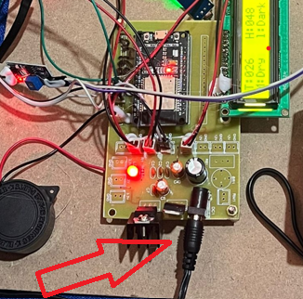

Figure 5.1 : Providing power supply to the system

5.2 Environmental conditions :

In below screenshot the LDR will display the environmental conditions of plant

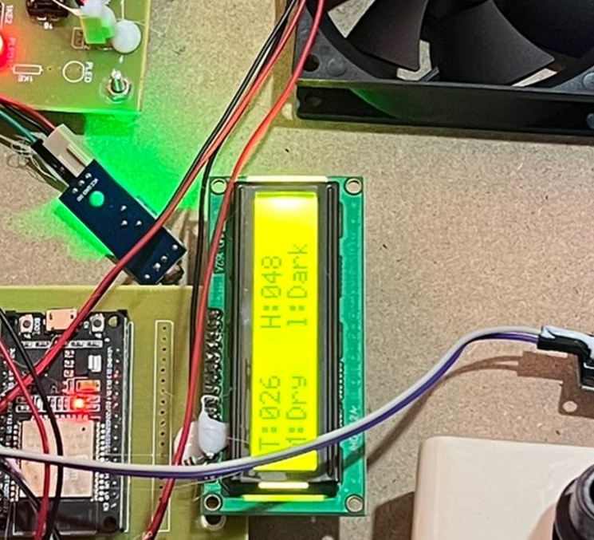

Figure 5.2 Result of the system
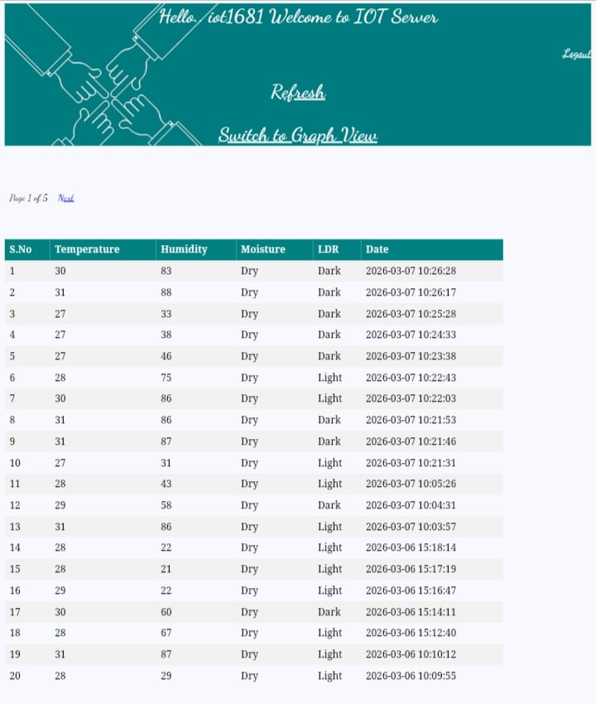

Figure 5.3 Cloud Monitoring result of the system

6. VALIDATION

6.VALIDATION

The validation of the proposed IoT-based plant growth monitoring system is carried out to ensure that the system functions accurately, reliably, and efficiently under different conditions. The system is tested by comparing the sensor readings (soil moisture, temperature, humidity, and light intensity) with standard measuring instruments to verify accuracy. The results show that the system provides reliable and consistent data with minimal deviation.

The system is tested by comparing the sensor readings (soil moisture, temperature, humidity, and light intensity) with standard measuring instruments to verify accuracy. The results show that the system provides reliable and consistent data with minimal deviation.
The functionality of the system is validated by observing real-time data transmission from the sensors to the cloud platform. Successful data updates on the dashboard confirm proper communication between the ESP32 microcontroller and the cloud server. Additionally, the alert system is tested by setting threshold values and verifying that notifications are generated when the parameters exceed the limits.
The system is also validated for usability and performance by testing remote access through web or mobile interfaces. Users are able to monitor environmental conditions from different locations without delay. Overall, the system demonstrates effective performance in real-time monitoring, data accuracy, and timely alert generation, proving it to be a reliable solution for smart plant growth management.

6.1 TEST CASES
Test Case ID | Input Condition | Expected Output | Actual Output | Status
TC01 | Temperature > 40°C | Fan ON, Buzzer ON | Fan ON, Buzzer ON | Pass
TC02 | Temperature ≤ 40°C | Fan OFF | Fan OFF | Pass
TC03 | Humidity > 85% | Fan ON, Buzzer ON | Fan ON, Buzzer ON | Pass
TC04 | Humidity ≤ 85% | Fan OFF | Fan OFF | Pass
TC05 | Soil Moisture = Dry | Pump ON, Display "Dry" | Pump ON, "Dry" shown | Pass
TC06 | Soil Moisture = Wet | Pump OFF, Display "Wet" | Pump OFF, "Wet" shown | Pass
TC07 | LDR detects Light | Display "Light" | "Light" shown | Pass
TC08 | LDR detects Dark | Display "Dark" | "Dark" shown | Pass
TC09 | WiFi Connected | Data sent to server | Datasent successfully | Pass
TC10 | WiFi Not Connected | Data not sent, retry | Retry/No send | Pass
TC11 | Normal Conditions | All devices OFF | All OFF | Pass
TC12 | Extreme Conditions (High temp + Dry soil) | Fan ON, Pump ON, Buzzer ON | All ON | Pass

Table 6.1 : Uploading dataset

7.CONCLUSION & FUTURE ASPECTS

7.CONCLUSION & FUTURE ASPECTS

In conclusion, the project has successfully achieved its objectives, showcasing significant progress and outcomes. The implementation and execution phases were meticulously planned and executed, leading to substantial improvements and insights. Looking ahead, the future aspects of the project hold immense potential. Future developments will focus on expanding the scope, integrating new technologies, and enhancing sustainability. These advancements will not only strengthen the existing framework but also open new avenues for growth and innovation, ensuring the project remains relevant and impactful in the long term. This strategic approach will drive continuous improvement and success.

7.1 PROJECT CONCLUSION

The Integrated Environment Analysis System for Plant Growth Monitoring using IoT provides an efficient and intelligent solution for modern agricultural challenges. By combining environmental sensors, IoT-enabled controllers, and cloud-based analytics, the system enables real-time monitoring and analysis of critical factors affecting plant growth. The block diagram-based architecture ensures seamless data flow from sensing to decision-making, reducing human intervention and operational errors.
The proposed system improves resource utilization by enabling timely irrigation and environmental control, thereby enhancing plant health and productivity. Remote monitoring and alert mechanisms allow users to take immediate corrective actions, minimizing crop losses due to adverse conditions. Compared to traditional methods, the system offers higher accuracy, scalability, and sustainability.
Overall, this IoT-based plant growth monitoring system supports precision agriculture and smart farming practices. It is adaptable for greenhouses, gardens, and large-scale farms, making it a valuable tool for improving agricultural efficiency and ensuring sustainable food production in the future.
7.2 FUTURE ASPECTS
Starting now, a different way could begin with newer sensors tracking things like soil nutrients, acidity, alkalinity, or CO2 levels. What plants grow follows real patterns these readings reveal. Down below is where key changes show up, guiding smarter choices in farming crops. Before time runs out, signs appear once tools start understanding plant behavior. Number trends may suggest future harvests, warn growers about health issues rising, also suggest shifts to match forecast conditions.
A fresh angle? Design a setup that manages water, brightness, and airflow without human intervention - minimal hands-on effort. Propelled by clean energy, solar systems fit smoothly into space, connecting distant farms. Even across vast areas, technologies such as LoRa or NB-IoT extend coverage beyond what you might think, still keeping costs low. Out in the fields, certain app layouts help farmers jump straight into their work. Tasks finish themselves sometimes, thanks to features that work without active data connections. Change begins quietly where it used to stall - screens lighting up spots that were previously out of reach.
Truth is, working together helped each person focus on what mattered - coding, setting up tests, fixing issues. Without consistent attendance from anyone, progress would’ve stalled constantly. Invisible effort unfolded every day, even when meetings ended, later at night, earlier than dawn. Heavy days? Their presence shifts something. In times when energy vanished, others appeared - without sound, carrying no need, just present. Their speech slipped in soft, quiet sparks - flickering until they burned bright. What felt impossible never really mattered. As mother kept watch for fatigue or irritability, stillness held sway. This absence of noise wasn’t unusual - it simply was. It wasn’t about big steps. Progress came from legs repeating the same path, step after step, never stopping.

8.BIBLIOGRAPHY

8.BIBLIOGRAPHY
8.1 REFERENCES
- Sarkar, A., Bharti, S. A., & Nirmalrani, V. — Integrated Environment Analysis System for Plant Growth Monitoring using IoT. Proceedings of the 3rd International Conference on Augmented Intelligence and Sustainable Systems (ICAISS), 2025.
- Mohan, S. & Arbaiy, N. — IoT-Based Plant Growth Monitoring System. Applied Information Technology and Computer Science, 6(2), 1609–1623, 2025.
- Absar, M. H., Mirza, G. F., Zakai, W., John, Y., & Mansoor, N. — Novel IoT-Based Plant Monitoring System. Engineering Proceedings, 32(1):12, 2023.
- Banke, V., Lende, D., Masal, G., Shevade, S., & Thamke, G. — IoT Enabled Plant Monitoring System. IJRASET, 2024.
- Sahu, K. K., Kumar, S., Taram, A., Rana, D. K., & Anjum, N. — IOT-Based Smart Plant Monitoring System using NodeMCU. i-manager Journal on Electrical Engineering, 17(2), 2023.
- Soetedjo, A. & Hendriarianti, E. — Development of an IoT-Based SCADA System for Monitoring of Plant Leaf Temperature and Air and Soil Parameters. Applied Sciences, 13(20), 11294, 2023.
- Putri, R. E., Lestari, N. U., Ifmalinda, F. A., Arlius, F., & Hasan, A. — Monitoring and Controlling System of Smart Mini Greenhouse Based on IoT for Spinach Plant. Int. J. Adv. Sci. Eng. Inf. Technol., 14(1), 2024.
- Khamil, K. N., Khoo, Y. Z., & Isa, A. N. — STM32-based IoT Monitoring System for an Indoor Plant. International Journal of Intelligent Systems and Applications in Engineering, 2025.
- Dada, T. J., Elekwa, O., Okhueleigbe, V., Ishiwu, J., Onyeyili, I., & Clarke, S. — IoT-Enabled Plant Growth Prediction and Health Monitoring System Using Sensor Fusion and Machine Learning Techniques. Path of Science, 2025.
- Puri, B. — IoT and AI-based Plant Monitoring System. International Journal of Machine Learning and Networked Collaborative Engineering, 4(3), 2021.
- Mhasekar, S. J., Mahajan, K. N., Murthy, D. N., Swarnkar, S. K., & Takale, D. G. — Plant Growth Analysis using IoT and Reinforcement Learning Techniques for Uncontrolled Environment. Journal of Information Systems Engineering and Management, 10(4s), 2025.
- Joshi, A., Sonika T., Tharani, M., & Singh, J. — IOT Based Smart Plant Monitoring System. IJRASET, 2024.

8.2 GITHUB LINK
vaishnavi-1232/Integrated-Environment-Analysis-System-for-plant-Growth

